# Visualize All Walks - Final Corrected Solution

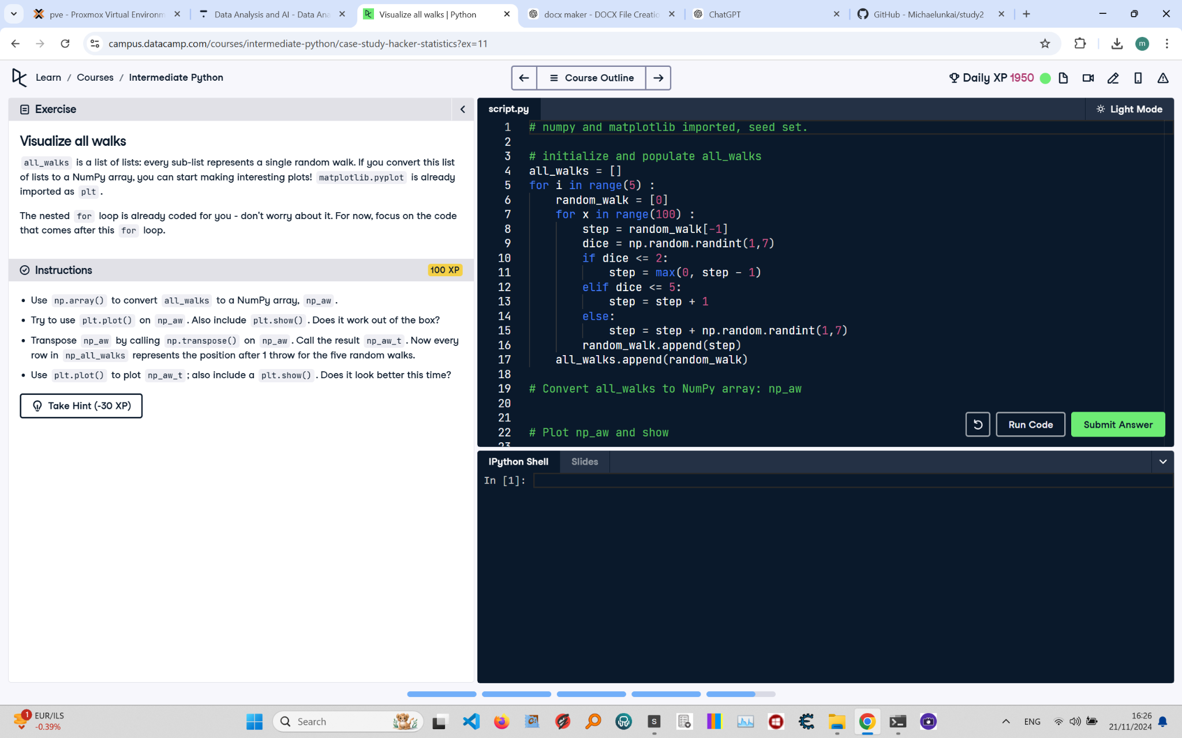

Below is the final corrected solution for the 'Visualize All Walks' exercise from the Python course. The image includes the instructions, code, and task details.

Final Corrected Solution:

# NumPy and matplotlib imported, seed set  
import numpy as np  
import matplotlib.pyplot as plt  
np.random.seed(123)  
  
# Initialize and populate all_walks  
all_walks = []  
for i in range(5): # Loop runs 5 times  
 random_walk = [0]  
 for x in range(100): # Loop runs 100 times for each walk  
 # Set step: last element in random_walk  
 step = random_walk[-1]  
   
 # Roll the dice  
 dice = np.random.randint(1, 7)  
   
 # Determine next step using max to prevent step from going below 0  
 if dice <= 2:  
 step = max(0, step - 1) # Move down but ensure step doesn't go below 0  
 elif dice <= 5:  
 step = step + 1 # Move up  
 else:  
 step = step + np.random.randint(1, 7) # Move up by a random value  
   
 # Append next_step to random_walk  
 random_walk.append(step)  
   
 # Append random_walk to all_walks  
 all_walks.append(random_walk)  
  
# Convert all_walks to NumPy array: np_aw  
np_aw = np.array(all_walks)  
  
# Plot np_aw and show  
plt.plot(np_aw)  
plt.show()  
  
# Clear the figure  
plt.clf()  
  
# Transpose np_aw: np_aw_t  
np_aw_t = np.transpose(np_aw)  
  
# Plot np_aw_t and show  
plt.plot(np_aw_t)  
plt.show()

Explanation:

1. Import numpy as np and matplotlib.pyplot as plt, and set the random seed using np.random.seed(123).

2. Initialize all_walks as an empty list to store the results of multiple random walks.

3. Use a for loop to repeat the random walk simulation 5 times, appending each completed random_walk to all_walks.

4. Convert the list all_walks into a NumPy array called np_aw using np.array(all_walks).

5. Plot the np_aw array using plt.plot(np_aw) and display the plot with plt.show().

6. Call plt.clf() to clear the figure, ensuring a clean plot for the next set of data.

7. Transpose the np_aw array to np_aw_t using np.transpose(np_aw), ensuring that each row represents a random walk.

8. Plot the transposed array np_aw_t using plt.plot(np_aw_t) and display it with plt.show(), showing each walk clearly.